1. From the desktop, click on the arrow on the bottom right near the clock and select “**Cisco AnyConnect Secure Mobility Client VPN**”.  You can also find VPN under Start -> All Programs -> Cisco -> Cisco AnyConnect Secure Mobility Client VPN

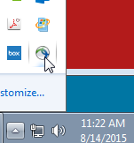

1. Make sure the correct server name is in the white box under “**Ready to connect**”

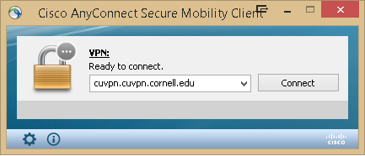

1. Select Connect
2. A Cisco AnyConnect box will pop-up and ask for your logon information.  Use **netid@fh-vpn** for your username and your **netid password** for the password.  Then click OK.

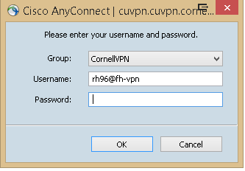

1. Now you should be connected to VPN.  A popup box will appear on the bottom right again confirming you’re connected.  You’ll also see a globe icon with a lock on the bottom right.
2. Open Remote Desktop by going to Start -> All Programs -> Accessories -> Remote Desktop Connection.
3. In the Remote Desktop Connection box type in your computer name **fh-your department code-computer name.human.cornell.edu.**
4. Finding your computer name (at the desktop), go to **Start** -> right click **My Computer** -> left click **Properties ->** A box will open with information about your computer. Scroll down to Computer Name (toward the bottom under the heading **Computer name, domain, and workgroup settings**). You’ll need this information to put into the Remote Desktop Connection space.****

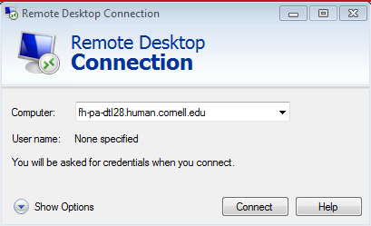

1. At this point you should see your MVR computer screen appear.  Just logon as normal.
2. When you’re finished, logoff your MVR computer as normal.  When you logoff, you will be disconnected from your computer.  Then all that’s left is to disconnect from VPN.  To do that go back to the arrow on the bottom right -> click on Cisco AnyConnect Secure Mobility Client (globe with a lock) -> Disconnect.

That’s it!